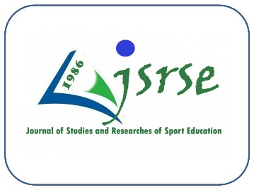

**Journal of Studies and Researches of Sport Education (JSRSE)**

A semi-annual scientific journal in the field of scientific research in sport sciences issued by the College of Education and Sport Sciences / University of Basra

**P-ISSN: (1818-1503) E- ISSN: (2789-6560)**

**Approval of the Author (s) Declaration Statement**

**Manuscript title:**

I / We, the undersigned, pledge:

* The manuscriptaddress affixed above is executed by us.
* The sequence of author(s) names in the manuscriptis as shown below.
* The manuscriptwas not taken from any published manuscriptpreviously, and the author(s) is/are responsible for its content.
* The manuscriptrepresents the opinions of the author(s), and it doesn’t necessarily represent the opinion of the publisher (Journal of Studies and Researches of Sport Education **JSRSE**).

|  |  |  |  |  |
| --- | --- | --- | --- | --- |
| Series | Full name | scientific title | Workplace | Signature |
| 1 |  |  |  |  |
| 2 |  |  |  |  |
| 3 |  |  |  |  |
| 4 |  |  |  |  |

Sequence (1) indicates the first Author (Senior Author), and sequence (2) indicates the second Author, and so on...

**Important note: The above pledge is filled out and then re-uploaded while sending the manuscript. Otherwise, the request will not be considered.**